Internship Task-1 Documentation – ‘Self Introduction Webpage’
1. Introduction
This task is to create a simple HTML webpage that displays my self-introduction.
Below is the explanation of the code and the purpose of each HTML tag used.
2. HTML Code
<html>
<head>
<title>Self Introduction</title>
</head>
<body>
<center>
<h1> Self Introduction</h1>
<p>My name is Pratiksha Murkute.</p>
<p>I am from Pune.</p>
<p>I have completed my Bachelor of Computer Science degree.</p>
<p>Currently pursuing Java Full Stack Developer Course.</P>
<h4>Thank You!</h4>
</center>
<!-- This is my first Task for the intership Programe. -->
</body>
</html>
3. Explanation of Each Tag
<html>
- The root tag of the webpage.
- All other HTML elements are written inside it.
<head>
- Contains information about the webpage that is not displayed on the screen.
<title>
- Sets the page title shown on the browser tab.
- In this program: Self Introduction
<body>
- Contains all visible content of the webpage (text, images, headings).
<center>
- Aligns all inside content to the center of the page.
- (Note: This is an old tag but still works.)
<h1>
- The largest heading.
- Used here for the page title Self Introduction.
<p>
- Paragraph tag used to display normal text lines.
- Used to write details about myself.
<h4>
- Smaller heading.
- Used for the closing line Thank You!
<!-- comment -->
- Adds comments inside the code.
- Comments do not appear on the webpage.
- Used here to note that this is my first internship task.
4. Output Screenshot
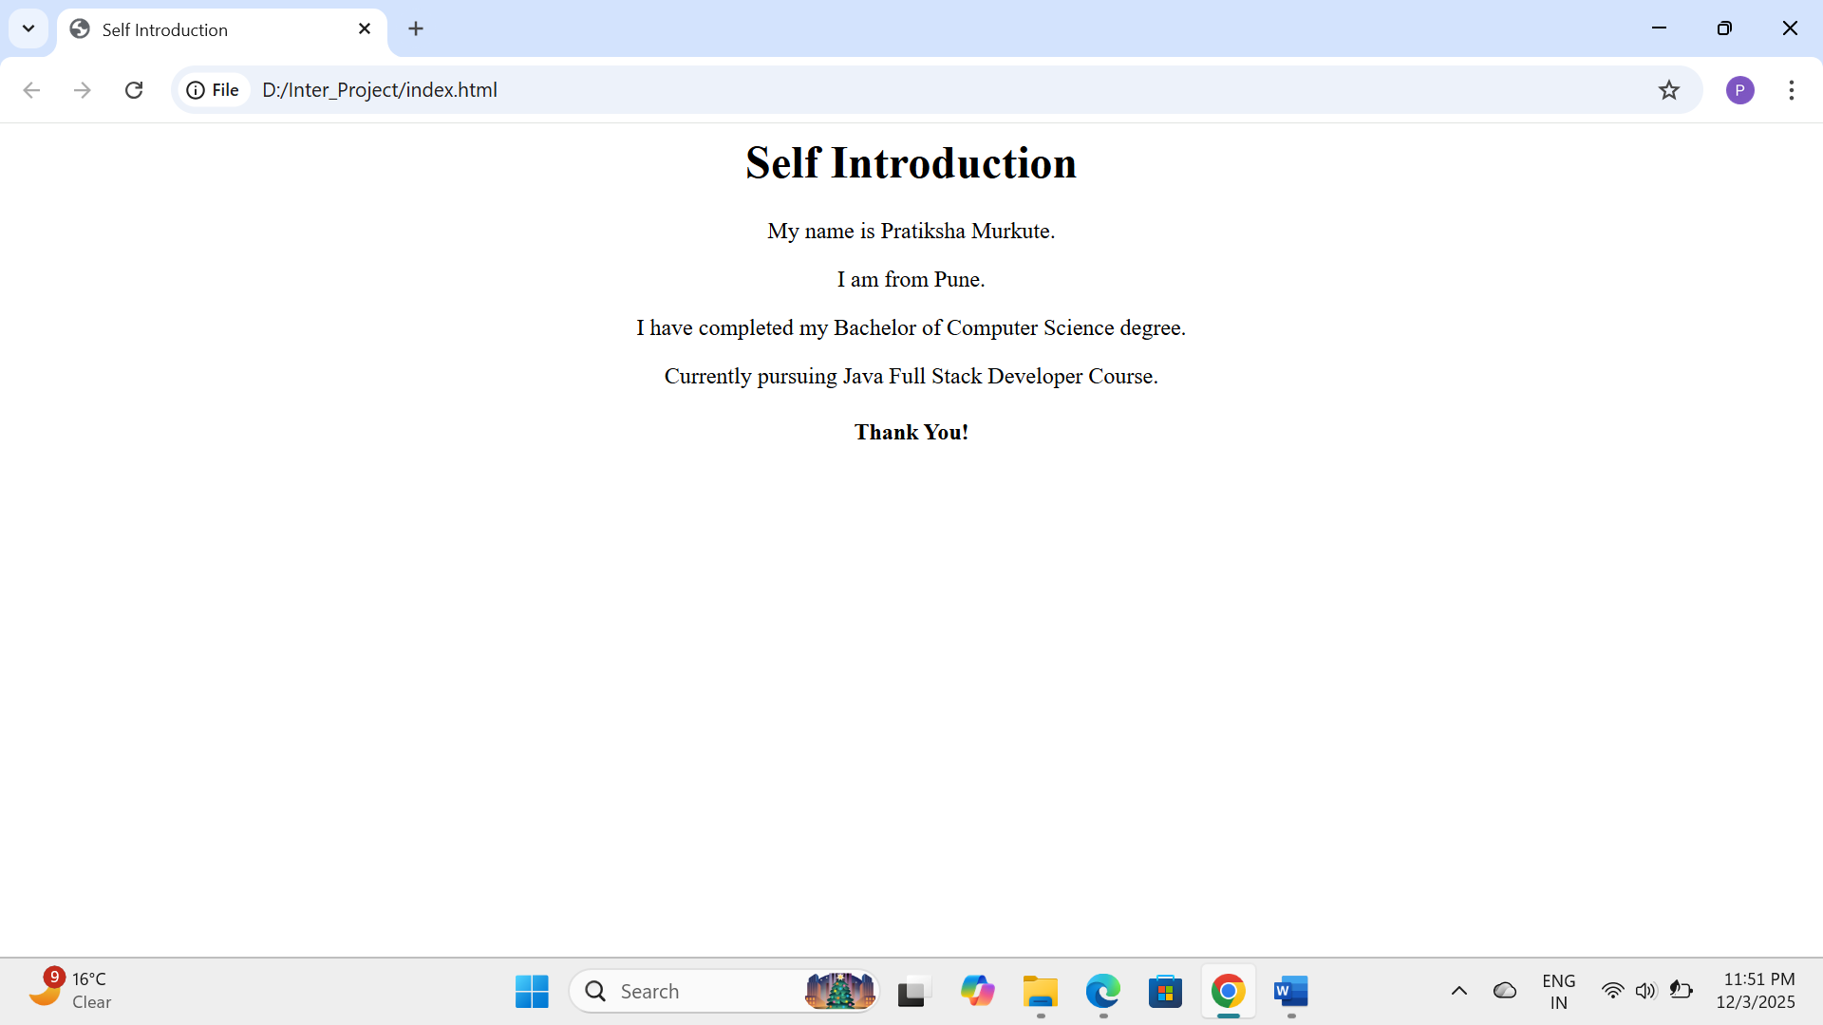

5. Conclusion
This task helped me understand basic HTML structure and how different tags work to display content on a webpage.

